ForecastIQ – Knowledge Transfer Document
- Introduction

  - Project Overview
ForecastIQ – Smart Sales Prediction Assistant is an AI-enabled forecasting application developed to enhance sales planning and decision-making. The solution integrates:
• SARIMA (Seasonal Autoregressive Integrated Moving Average) for statistical sales forecasting.
• Azure OpenAI GPT models for conversational insights and natural language interaction.
• Azure Cognitive Search for retrieval of business knowledge and contextual data.
• Stream lit as the front-end interface for interactive data upload, visualization, and chat functionality.
This integration ensures accurate forecasting while enabling users to interact with data through a conversational interface, making insights accessible to both technical and non-technical stakeholders.
  - Problem Statement
Traditional forecasting and reporting methods present several challenges:
• Manual and Time-Consuming – Reliance on spreadsheets and manual updates delays decision-making.
• Limited Analytical Depth – Static dashboards lack flexibility for scenario analysis.
• Complexity of Forecast Models – Requires technical expertise to build, interpret, and maintain.
• Lack of Interactivity – Business teams cannot engage with data dynamically or ask contextual questions.
ForecastIQ addresses these challenges by combining statistical modeling with conversational AI. This allows users to:
• Generate forecasts automatically from historical data.
• Perform “what-if” analyses with updated datasets.
• Ask natural language questions to derive insights from both forecasts and business knowledge sources.
• Enable cross-functional teams to make informed, data-driven decisions without technical barriers.

  - High-Level Architecture
The architecture of ForecastIQ – Smart Sales Prediction Assistant is designed to ensure scalability, modularity, and seamless integration with Azure services. At a high level, the system consists of four core layers:
1.3.1 User Interaction Layer
• Stream lit Web App serves as the interface for all user interactions.
• Enables Excel data upload, forecast visualization, and conversational chat.
• Provides a unified experience for both technical and non-technical users.
1.3.2 Forecasting & Analytics Layer
• SARIMA Model (via stats models) performs time-series forecasting based on historical sales data.
• Automated model selection optimizes parameters (p, d, q, P, D, Q, s) for best accuracy.
• Outputs include:
• Forecast plots
• Key metrics (MAPE, RMSE, etc.)
• Comparative analysis across datasets
1.3.3 AI & Knowledge Layer
• Azure OpenAI GPT (GPT-3.5) powers natural language understanding and contextual conversations.
• Azure Cognitive Search retrieves relevant business knowledge (RAG – Retrieval-Augmented Generation).
• Together, these components enable:
• Natural language Q&A on forecasts
• Context-aware business insights
• Follow-up conversations with memory
1.3.4 Integration & Deployment Layer
• Azure Services Used:
• Azure OpenAI Service – For GPT-based conversational insights.
• Azure Cognitive Search – For indexed document search and RAG.
• Azure App Service / Containerization (optional) – For deployment scalability.
• Python (Stream lit + Lang Chain) forms the backend logic.
• Modular structure ensures easy extension for additional models or data sources.
1.3.5 End-to-End Flow
1. User uploads dataset / asks a query via Stream lit.
2. Forecasting pipeline (SARIMA) generates predictions.
3. AI Layer (Azure OpenAI + Search) interprets queries, retrieves context, and formulates responses.
4. Response (charts, text, insights) is presented back to the user in the web interface.
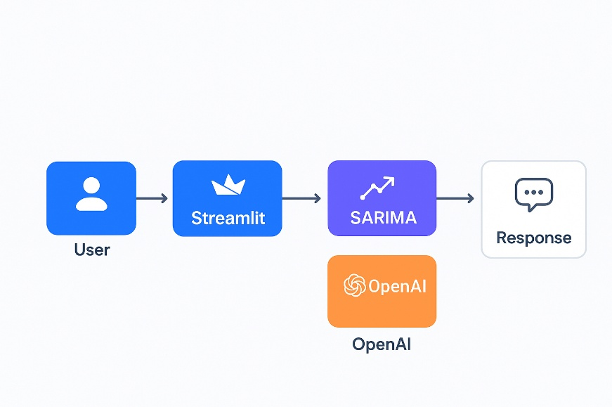
- Technology Stack

• Frontend: Stream lit (Python)
• Forecasting Model: SARIMA (stats models)
• AI Assistant: Azure OpenAI (GPT-3.5-turbo)
• Knowledge Retrieval: Azure Cognitive Search (RAG)
• Data Handling: Pandas, JSON serialization
• Hosting: Local deployment with Azure Services

- Azure Service Setup

3.1 Azure Subscription (ForecastIQ build with Azure 1-month free trial)

3.2 Azure OpenAI

Overview
Azure OpenAI Service provides enterprise-grade access to OpenAI’s powerful language models (GPT-3.5, GPT-4, etc.) through Azure’s secure cloud infrastructure. It enables natural language understanding, text generation, summarization, and context-aware conversations with enterprise compliance, scalability, and governance.
Application in ForecastIQ
• Powers the chat assistant within the Stream lit app.
• Handles natural language queries such as:
• “Compare sales growth between Q1 and Q2.”
• “What is the forecast for next 6 months ?”
• Provides contextual insights by combining forecast outputs (from SARIMA) with indexed knowledge (via Cognitive Search).
• Ensures follow-up question handling (e.g., “And what about last year’s trend?”).
Why Needed
• Manual analysis of forecast data is time-consuming and requires technical expertise.
• Azure OpenAI provides a business-friendly conversational interface for exploring forecasts.
• Being hosted on Azure ensures data security, compliance, and scalability compared to public OpenAI endpoints.
Portal home page Azure OpenAI Create Fill in Subscription, Resource Group (create new if already didn’t exist), Region (East US) Review + Submit
Go to your resource under Azure OpenAI Click Go to Azure AI Foundry Portal In sidebar under “shared resources” go to Deployment Deploy Model (base) Select model to use (GPT 3.5 Turbo used in ForecastIQ)
Under My Assets go to your deployed model Endpoint for API key and URL

  - Azure Blob Storage
Overview
Azure Blob Storage is a scalable object storage solution for unstructured data such as Excel files, CSVs, documents, and logs. It supports secure data access, lifecycle management, and easy integration with analytics services.
Application in ForecastIQ
• Used to store uploaded Excel files containing sales data.
• Acts as a data lake where historical forecasts, updated datasets, and processed results can be stored.
• Provides persistent storage so that forecasting runs are reproducible and auditable.
• Enables future expansion (e.g., automated pipelines fetching fresh sales data from Blob).
Why Needed
• Without persistent storage, uploaded datasets would be session-specific and lost.
• Blob Storage ensures data centralization for analysis across multiple users/teams.
• Scales seamlessly as data volume grows (e.g., from MBs → GBs → TBs).
Portal home page Storage account Create Primary Service (Azure Blob) Review + Submit
Go to your Storage Upload Upload your data (JSON here)

  - Azure AI Search

Overview
Azure Cognitive Search is a cloud-based search-as-a-service solution that enables indexing, semantic search, and retrieval-augmented generation (RAG). It allows structured and unstructured business documents to be ingested, indexed, and queried in natural language.
Application in ForecastIQ
• Serves as the knowledge base for the assistant.
• Indexes uploaded business documents (e.g., sales policies, category notes, past reports).
• Enables contextual Q&A by retrieving relevant passages/documents when users ask queries.
• Example:
• User: “What were the low-performing SKUs last year?”
• System: Uses Cognitive Search to fetch relevant data, then GPT explains with context.
Why Needed
• Forecasting models alone cannot answer business knowledge queries (e.g., reasons for category decline, campaign details).
• Cognitive Search bridges this gap by providing retrieval + context for GPT.
• Supports RAG pipeline → making responses factual, context-rich, and grounded.

Portal Home page AI Search Create Review + Create
Go to your AI Search Import data Data Source (Azure Blob Storage) Parsing (choose according to your data, JSON Array in ForecastIQ) Customize Target Index (mark all string type data searchable and all other filterable, retrievable, sortable) All your heading should be visible Create an Index Under Search Management you can see your indexes
Under keys for API Key and Under Overview the URL

Setup complete, you should have:
AZURE_SEARCH_ENDPOINT
AZURE_SEARCH_API_KEY
AZURE_SEARCH_INDEX
AZURE_OPENAI_ENDPOINT
AZURE_OPENAI_API_KEY
AZURE_OPENAI_DEPLOYMENT

All these are used in the code for using and interconnecting the Azure services.

- Code Walkthrough

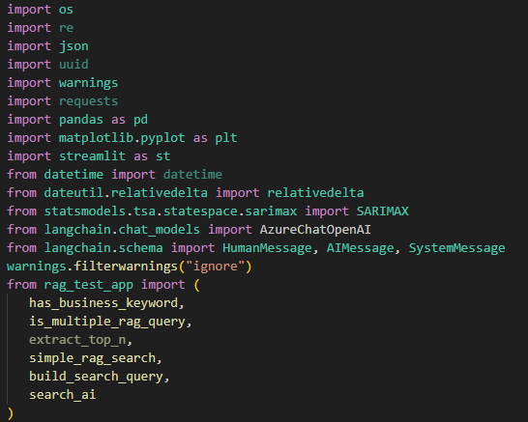

• Pulls in Stream lit for UI, pandas for data, matplotlib for charts.
• SARIMAX (stats models) is your time-series model.
• Lang Chain wrappers provide a clean message abstraction for the Azure OpenAI chat model.
• RAG helpers (from rag_test_app.py) handle keyword detection, query shaping, and Azure Cognitive Search calls.
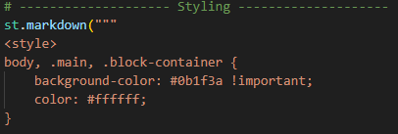
Page config and custom styling (UX), frontend
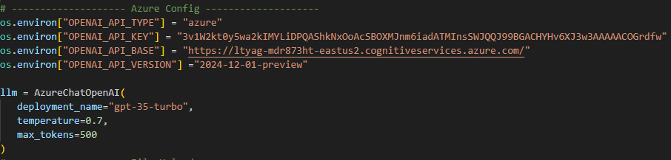
Environment and LLM Client: API and Endpoint will be called further, temperature: creativity and randomness of the LLM replies, max_tokens : limiting the token output from the LLM

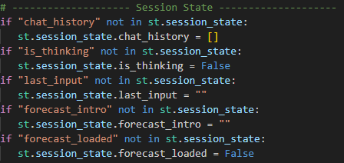
Session State for chat history and forecast cache, maintains conversational continuity and model output reuse across user turns

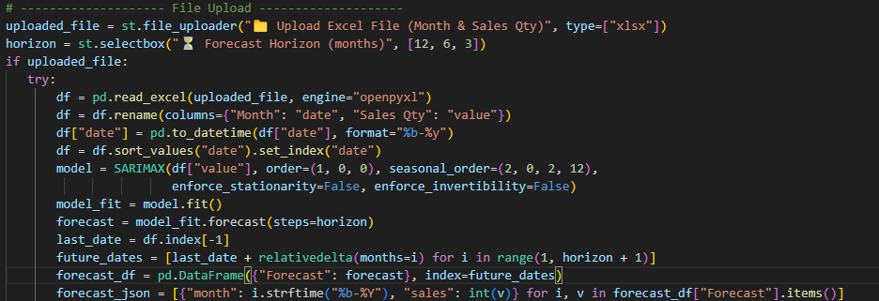
File upload, Horizon upload, normalizing date value columns
Sarima fitting and forecasting
Forecasted values converted into Json to be fed into the LLM

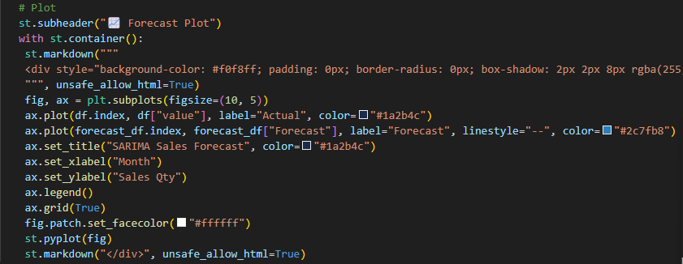
Forecast Visualization: historical vs forecast
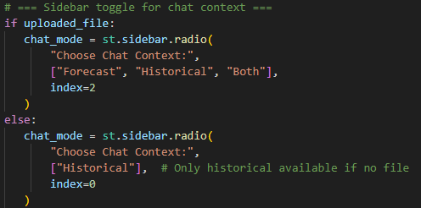
Allow user to choose the mode of conversation, forecastonly forecast data is used, historicalonly rag is used, both combine both
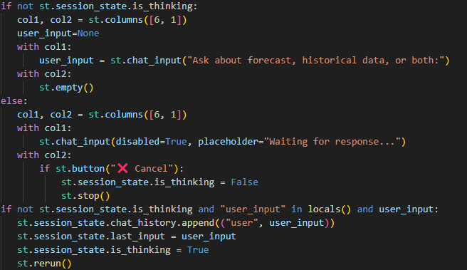
Input field with thinking state control
Cancel button
Capturing user input, save query in chat history, mark it as last inputensures input, processing, response happens seamlessly

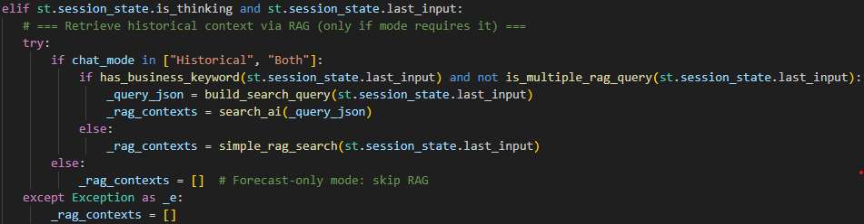
Fetch historical insights (RAG) when chat mode in historical or both

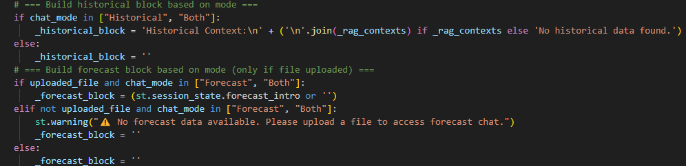
Building context Blocks (historical block and forecast block) that will be fed to the LLM
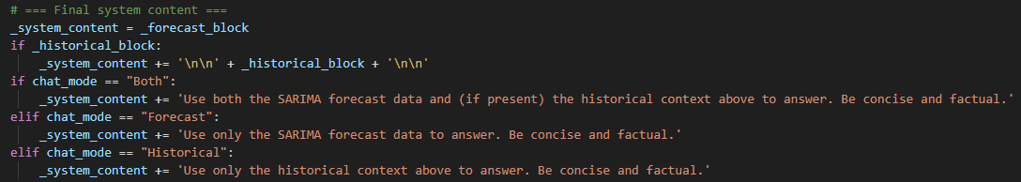
Constructing final system prompt
Add instruction for LLM based on the chat mode and forces factual and concise answer
Prevents model from mixing data sources incorrectly

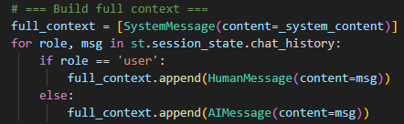
Prepare full conversational context/memory
Starts with system message (forecast + historical)
Then appends user queries + LLM replies from history
This enable follow up Q/A

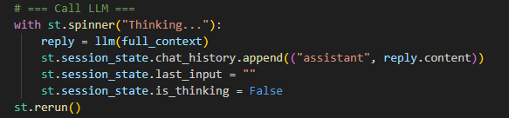
Call LLM and Save Response
Sends full context to LLM, save replies to chat history and resets last input
Creates a smooth chat loop, user inputAI thinkingLLM responseready for next input
Summary
This is the conversation engine of your ForecastIQ app:
• Handles user input, manages thinking state, and enables cancelling.
• Dynamically pulls in SARIMA forecasts + historical RAG insights.
• Builds a structured system prompt depending on chat mode.
• Maintains full chat memory for contextual conversations.
• Streams responses back into the chat UI.

- Application Workflow
This section explains the end-to-end flow of the ForecastIQ – Smart Sales Prediction Assistant, showing how different Azure services, models, and the UI interact to deliver forecasts and insights.
Stepwise Flow
1. Dataset Upload
• User uploads an Excel file containing historical sales data.
• File is securely stored in Azure Blob Storage for persistence.
2. Data Preprocessing & Forecasting
• Application reads the uploaded data.
• SARIMA model selection: The app automatically tests multiple SARIMA parameter combinations and selects the best based on MAPE (Mean Absolute Percentage Error).
• Generates forecasted values for upcoming months.
3. Knowledge Base (RAG Layer)
• Processed data and metadata (like top products, categories, growth/decline months) are indexed into Azure AI Search.
• Enables semantic + keyword search for natural language queries.
4. User Query Handling (LLM + RAG)
• User enters queries like “Which month had the lowest sales?”.
• Query flow:
• First → Azure AI Search retrieves relevant facts.
• Then → Azure OpenAI (GPT) processes query + search results + forecast data.
• Produces a contextual, human-like response.
5. UI Interaction (Stream lit Frontend)
• Forecasts shown as interactive plots (historical + future trends).
• Chat window supports multi-turn Q&A with memory (follow-ups).
• User can re-upload updated Excel to instantly compare new forecasts

- Deployment & Hosting
Current Hosting (Prototype Phase)
• For development and demo:
• Hosted on Stream lit Community Cloud / Local Machine.
• Provides easy testing and quick iterations.
• Backend services used during hosting:
• Azure OpenAI – For LLM-based conversational insights.
• Azure Cognitive Search – For RAG-based retrieval.
• Azure Blob Storage – For storing uploaded Excel files.

- Testing & Validation
7.1 Testing Objectives
• Validate data upload & processing (Excel → Forecast pipeline).
• Verify SARIMA forecasting accuracy.
• Ensure LLM responses are relevant and contextual.
• Test RAG retrieval from Azure Cognitive Search.
• Confirm end-to-end workflow stability (Upload → Forecast → Chat → What-if analysis).
7.2 Types of Testing
1. Unit Testing
• Tests individual functions (e.g., forecast generation, Excel parsing).
• Example: Validate SARIMA model fitting with different time-series datasets.
2. Integration Testing
• Tests how components work together.
• Example: Excel upload → Data processing → Forecast → Chat-based insight.
3. System Testing
• Tests the app.
• Example: User uploads data, forecasts generate, LLM gives insights.
4. User Acceptance Testing (UAT)
• Run with sample business datasets.
• Validate whether insights are understandable and useful for sales teams.

  - Test Scenarios
Test Case ID | Scenario | Steps | Expected Result
1 | Excel Upload | Upload valid excel file | Data uploads successfully
2 | Excel Validation | Upload file with missing value | System prompts error
3 | Forecast Generation | Run SARIMA forecast on dataset | Accurate prediction chart
4 | LLM Chat | Ask “which month has lowest sales?” | LLM returns correct month
5 | RAG Search | Query historical insights | Retrieved knowledge displayed

- Monitoring & Logging
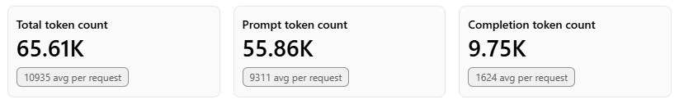
Total token usage for the whole development and testing phase was 65.61 thousand.
LLM was capped at 500 token per response and the whole chat history is fed as an input every time that is why completion token is far less that prompt token.
55.86K input tokens Rs 2.42
9.75K output token Rs 1.27 1 token approx. one English word
Total 65.61K token Rs 3.69

So, total LLM (GPT 3.5 TURBO) cost for development and testing phase came Rs 3.69.

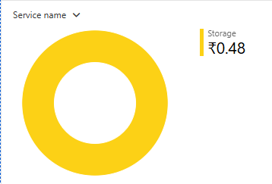

Azure blob storage cost came Rs 0.48



Azure AI Search costed nothing as we used free tier
So total development and testing of ForecastIQ came Rs 4.17

- Future Enhancements

ID | Function | Value | Notes
1 | Auto select best model for the forecast | Accuracy | Compare different model on historic data and select the best one (MAPE) for the forecast
2 | Persistent chat + Sharing | Collaboration | Multiple chat, chat download, chat share, chat store
3 | Azure App Deployment | Scale up | App availability to every user that has access on cloud
4 | Semantic search + Vector Index | Relevance of data | RAG implementation can be highly improved
5 | Batch ingestion pipeline | Scale up | Scheduled loads to Blob and Search

- Appendix

10.1 Glossary of Terms
• SARIMA (Seasonal Autoregressive Integrated Moving Average): A time-series forecasting model that captures trend + seasonality.
• RAG (Retrieval-Augmented Generation): AI approach where external knowledge (e.g., Excel data, Azure Search) is retrieved and supplied to the LLM.
• LLM (Large Language Model): AI model trained to understand and generate human-like text.
• Token: The smallest unit of text processed by the LLM (~4 characters or ~0.75 words).
• ForecastIQ: Name of the developed app – Smart Sales Prediction Assistant.
• Blob Storage: Azure storage service used to store raw files like Excel uploads.
• Cognitive Search: Azure service that indexes and retrieves structured/unstructured data for RAG queries.

10.2 Error Handling Reference
Error Case | Handling Strategy
Invalid file type upload | Display: “Please upload a valid excel file”
Empty Excel columns | “Data missing in file”
API Timeout | Retry request
Cognitive search no result | Empty historical block

  - References
• Streamlit Documentation
• Azure Cognitive Search Docs
• Azure OpenAI Service Docs
• LangChain Docs
• Statsmodels (SARIMA) Docs

